07-Contact-Manage-Reply

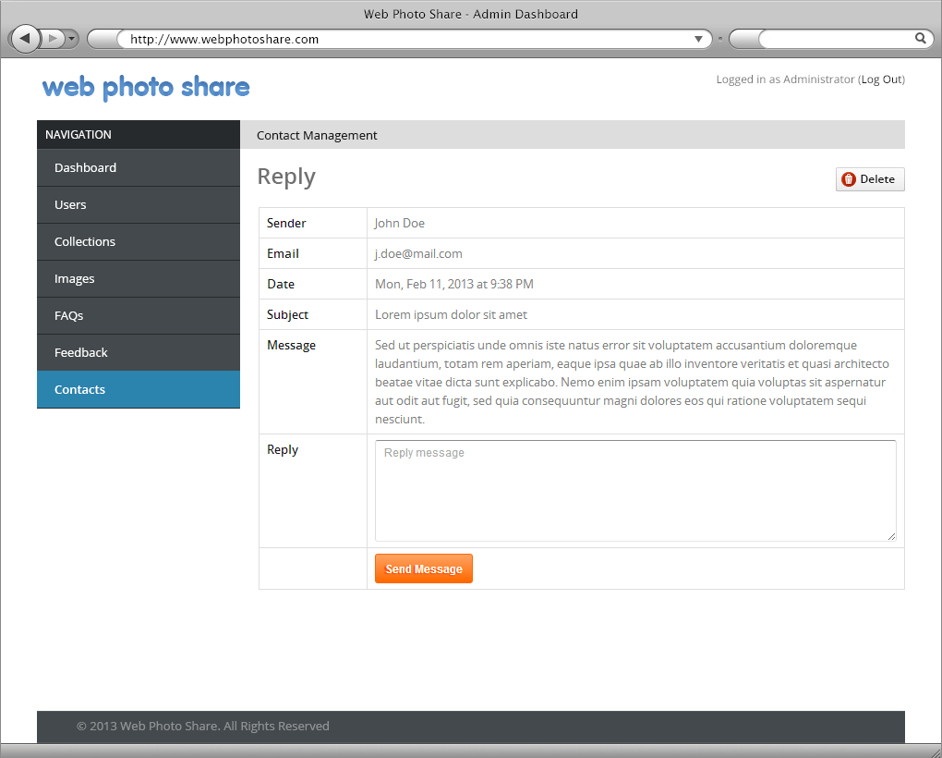

|  |  |  |  |  |  |  |
| --- | --- | --- | --- | --- | --- | --- |
| No. | Name | Type | Validation | Event | Description | Status |
| 1 | btnDelete | Button |  | Click | Delete Contact | Enable |
| 2 | txtReply | Textbox | Not null |  | Content Reply | Enable |
| 3 | btnSend | Button |  | Click | Process Send Reply | Enable |

07-Contact-Manage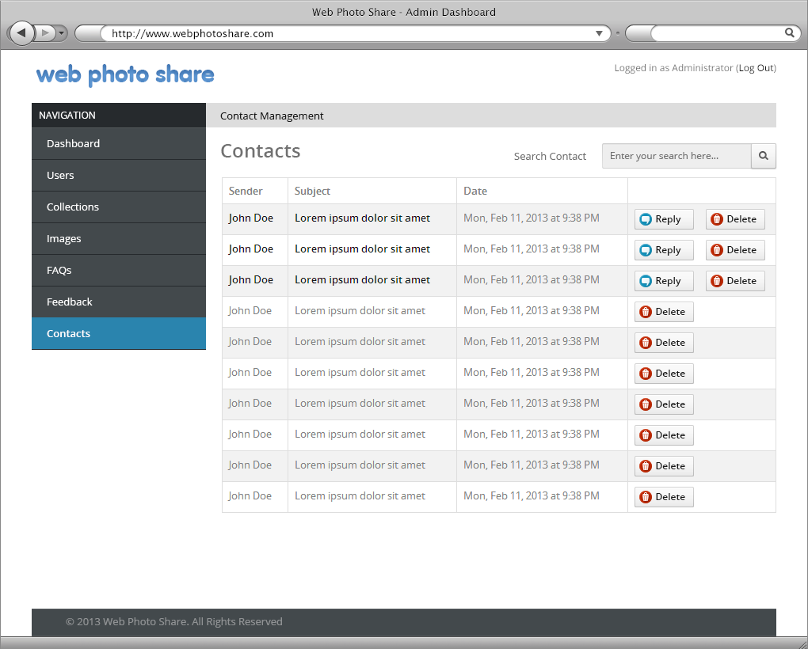

|  |  |  |  |  |  |  |
| --- | --- | --- | --- | --- | --- | --- |
| No. | Name | Type | Validation | Event | Description | Status |
| 1 | btnDelete | Button |  | Click | Delete Contact | Enable |
| 2 | btnReply | Button |  | Click | Content Reply | Enable |

06-FAQs-Manage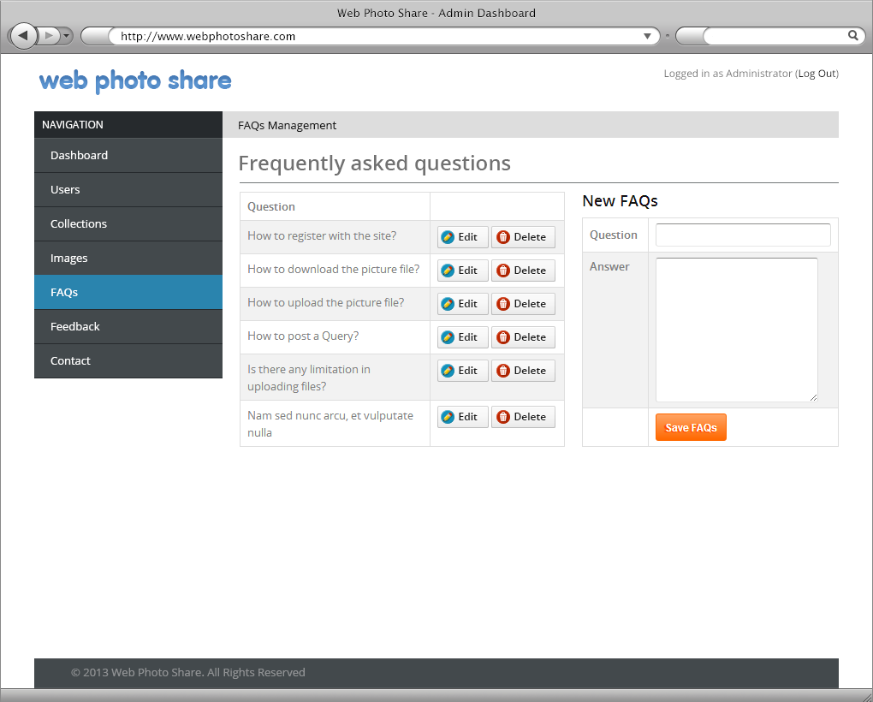

|  |  |  |  |  |  |  |
| --- | --- | --- | --- | --- | --- | --- |
| No. | Name | Type | Validation | Event | Description | Status |
| 1 | btnEdit | Button |  | Click | Edit Question | Enable |
| 2 | btnDelete | Button |  | Click | Delete Question | Enable |
| 3 | txtQuestion | Textbox | Not Null |  |  | Enable |
| 4 | txtAnswer | Textbox | Not Null |  |  | Enable |
| 5 | btnSave | Button |  | Click | Save FAQs | Enable |

05-Image-Manage-Edit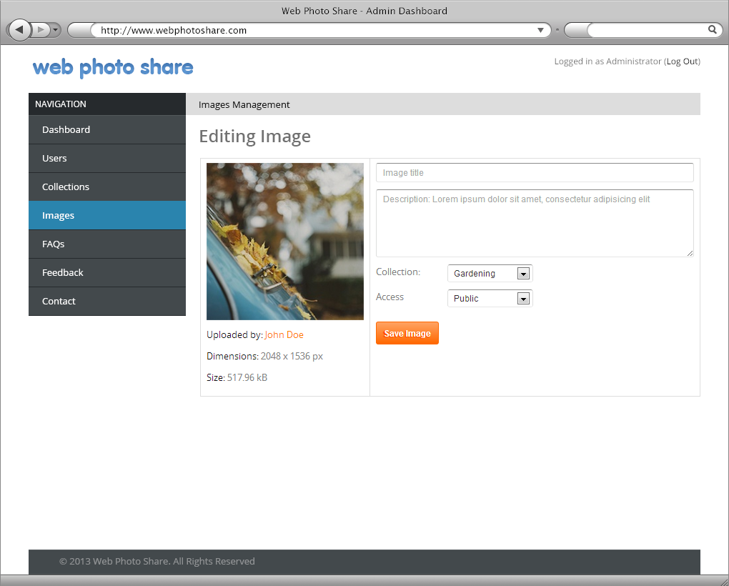

|  |  |  |  |  |  |  |
| --- | --- | --- | --- | --- | --- | --- |
| No. | Name | Type | Validation | Event | Description | Status |
| 1 | txtTitle | Textbox | Not Null |  | Title of Image | Enable |
| 2 | txtDescription | Textbox |  | Click | Depscription of Image | Enable |
| 3 | cboCollection | Combobox |  |  |  | Enable |
| 4 | cboAccess | Combobox |  |  |  | Enable |
| 5 | btnSave | Button |  | Click | Save Image | Enable |

05-Image-Manage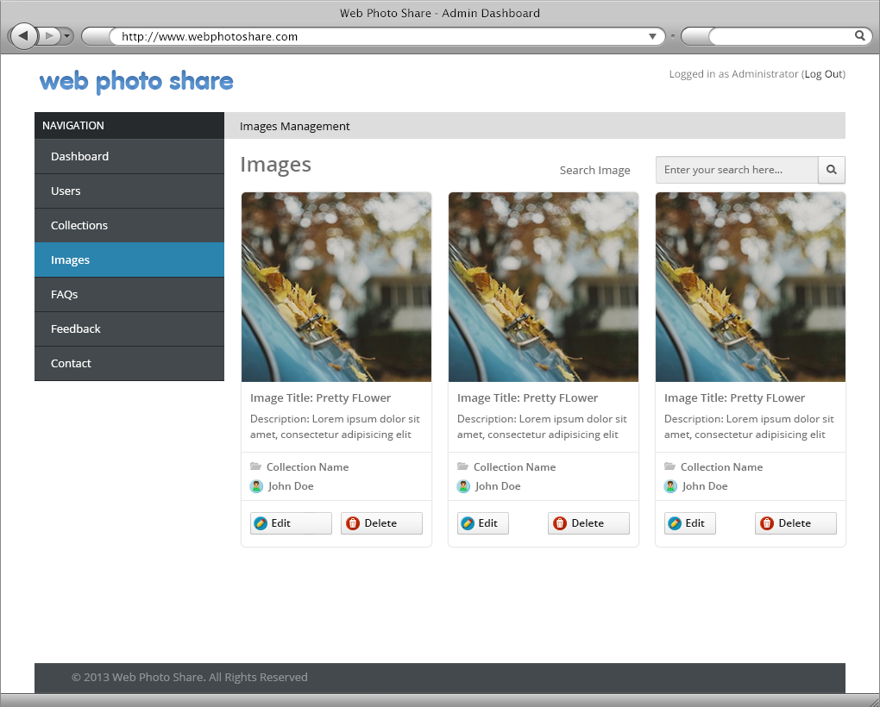

|  |  |  |  |  |  |  |
| --- | --- | --- | --- | --- | --- | --- |
| No. | Name | Type | Validation | Event | Description | Status |
| 1 | txtSearch | Textbox | Not Null |  | Search Image | Enable |
| 2 | btnSearch | Button |  | Click | Start Search | Enable |
| 3 | btnEdit | Button |  | Click |  | Enable |
| 4 | btnDelete | Button |  | Click | Delete Image | Enable |

04-Collection-Manage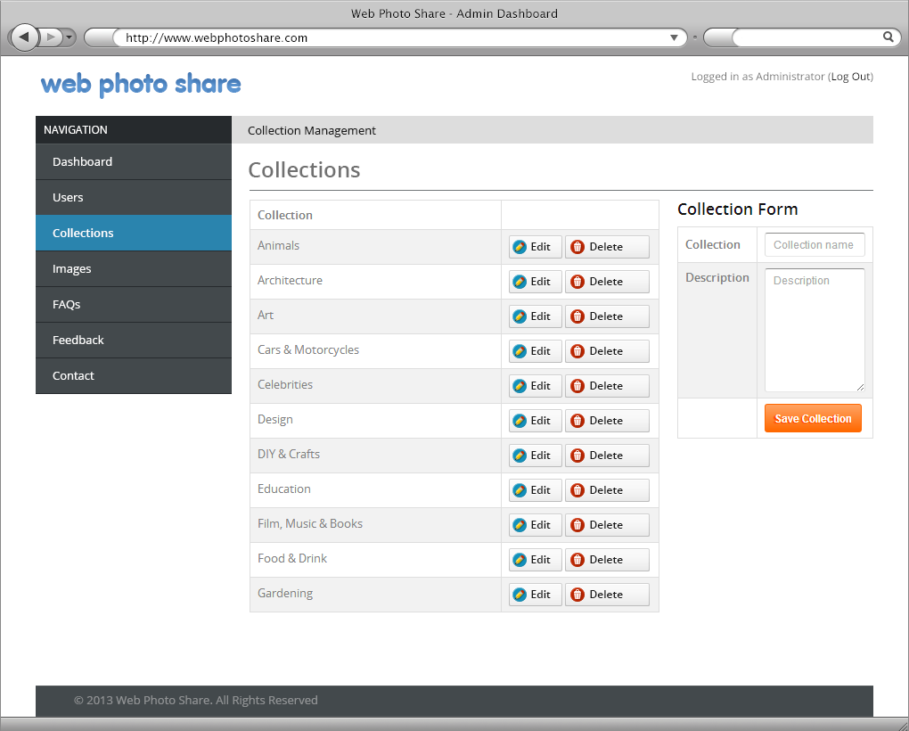

|  |  |  |  |  |  |  |
| --- | --- | --- | --- | --- | --- | --- |
| No. | Name | Type | Validation | Event | Description | Status |
| 1 | btnEdit | Button |  | Click | Edit Question | Enable |
| 2 | btnDelete | Button |  | Click | Delete Question | Enable |
| 3 | txtCollection | Textbox | Not Null |  |  | Enable |
| 4 | txtDescrption | Textbox | Not Null |  |  | Enable |
| 5 | btnSave | Button |  | Click |  | Enable |